Lab 3: Introduction to Scapy

**Screenshots of code put in pdf, but also attached in assignment**

Question 1:

First part was to get all IP addresses from the subnet: 10.20.111.0 – 10.20.111.3

Second part was to remove the broadcast and network IP (First and Last).

Code:

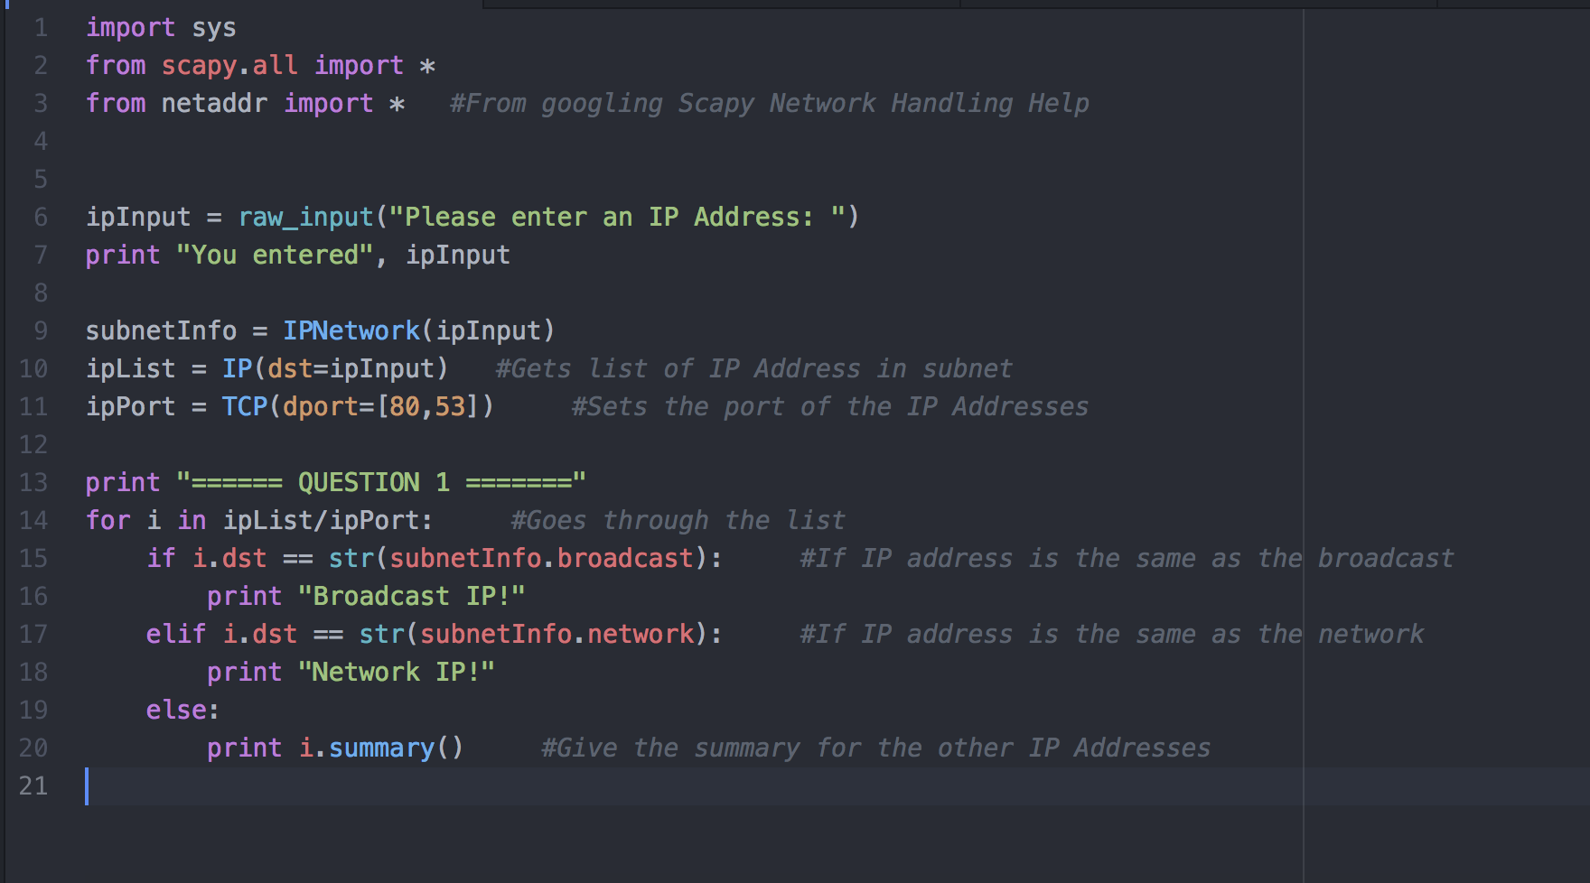

Screenshot:

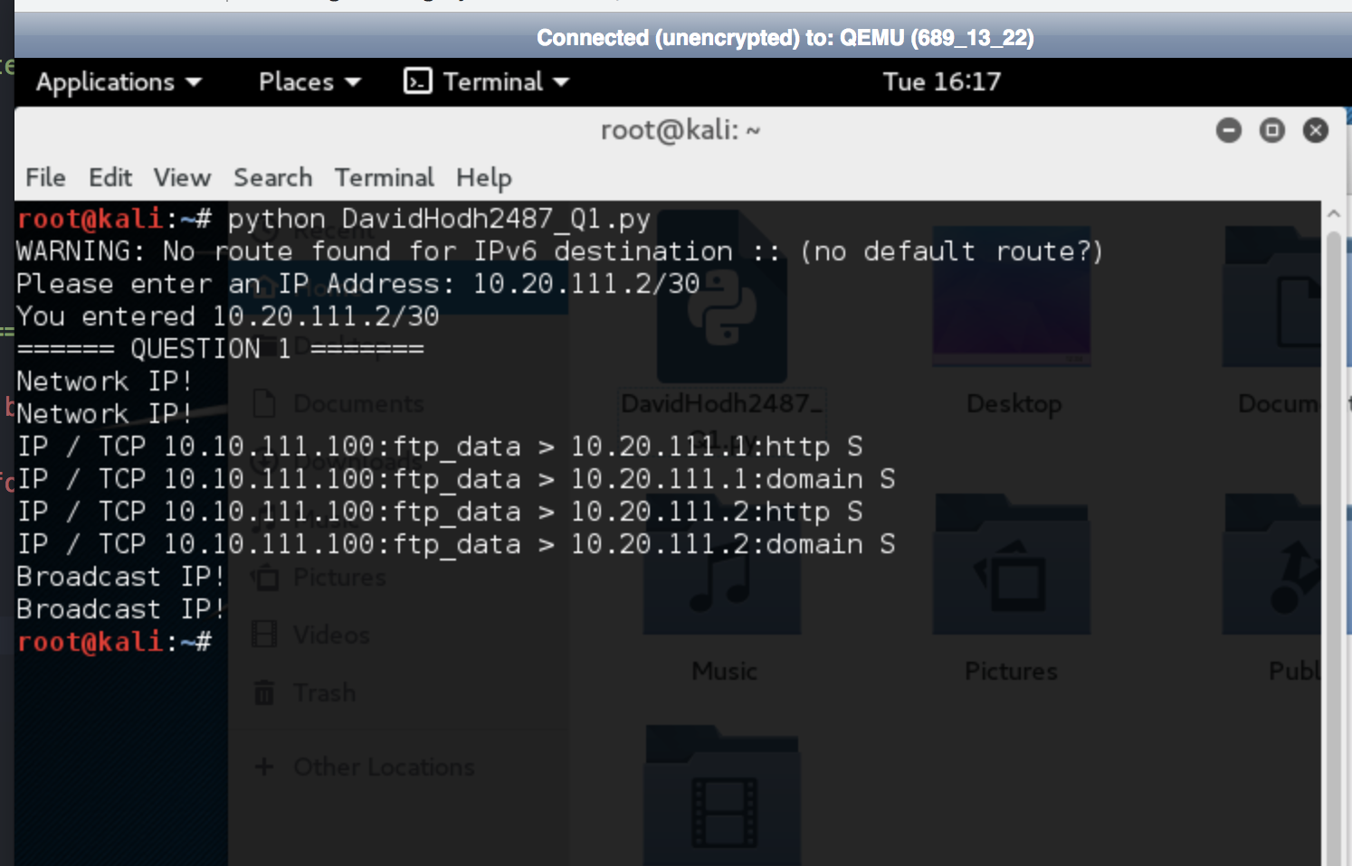

Question 2:

Send an ICMP packet from the BT5 machine to a specified IP address and get the reply. Give the screenshots of the packets generated and the replies.

All this question asked is to send an ICMP packet. One line of code used.

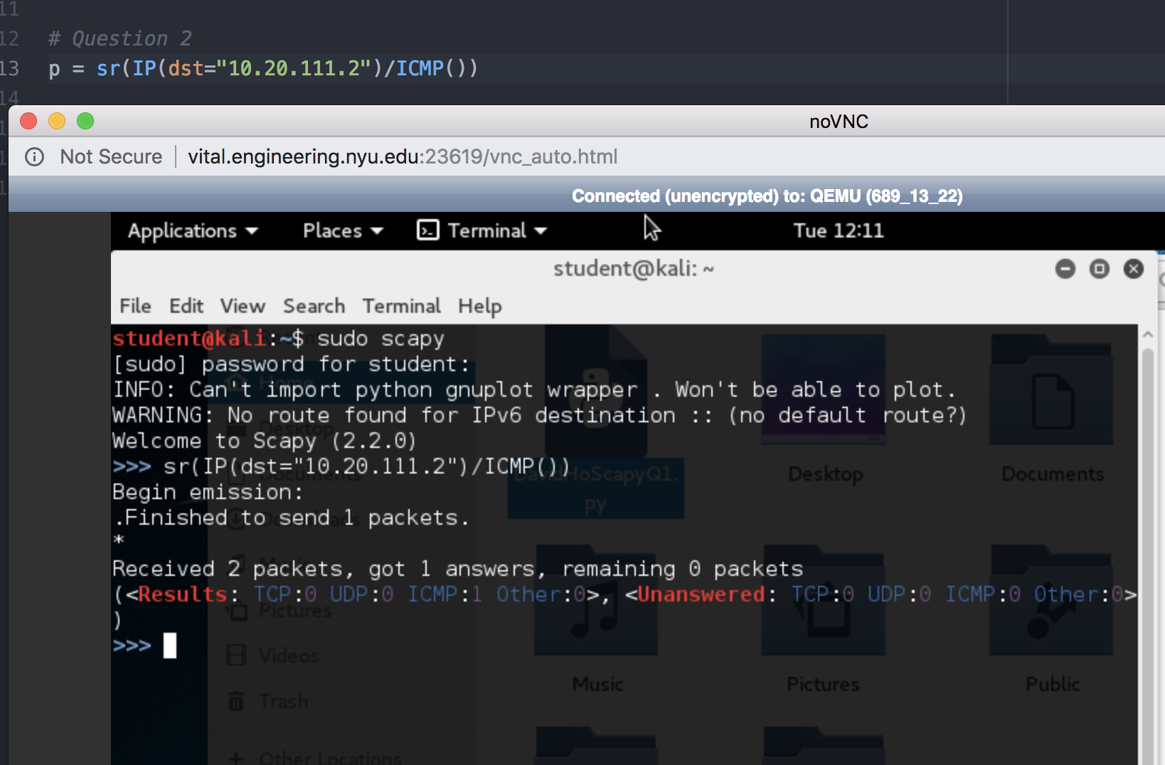

Question 3:

For this question, we had to make a traceroute.

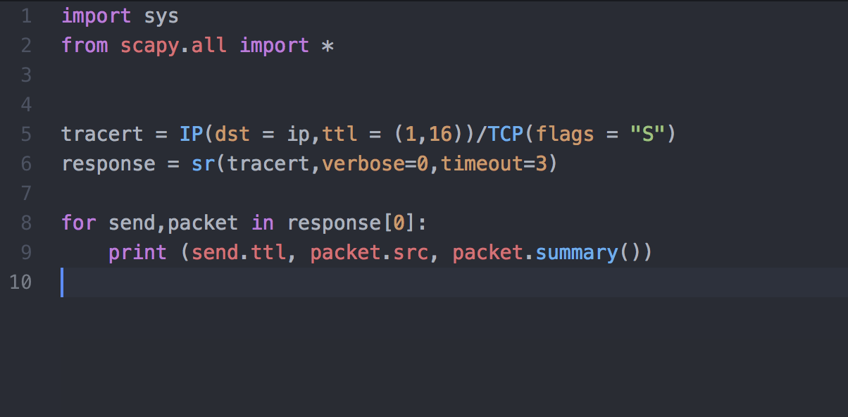

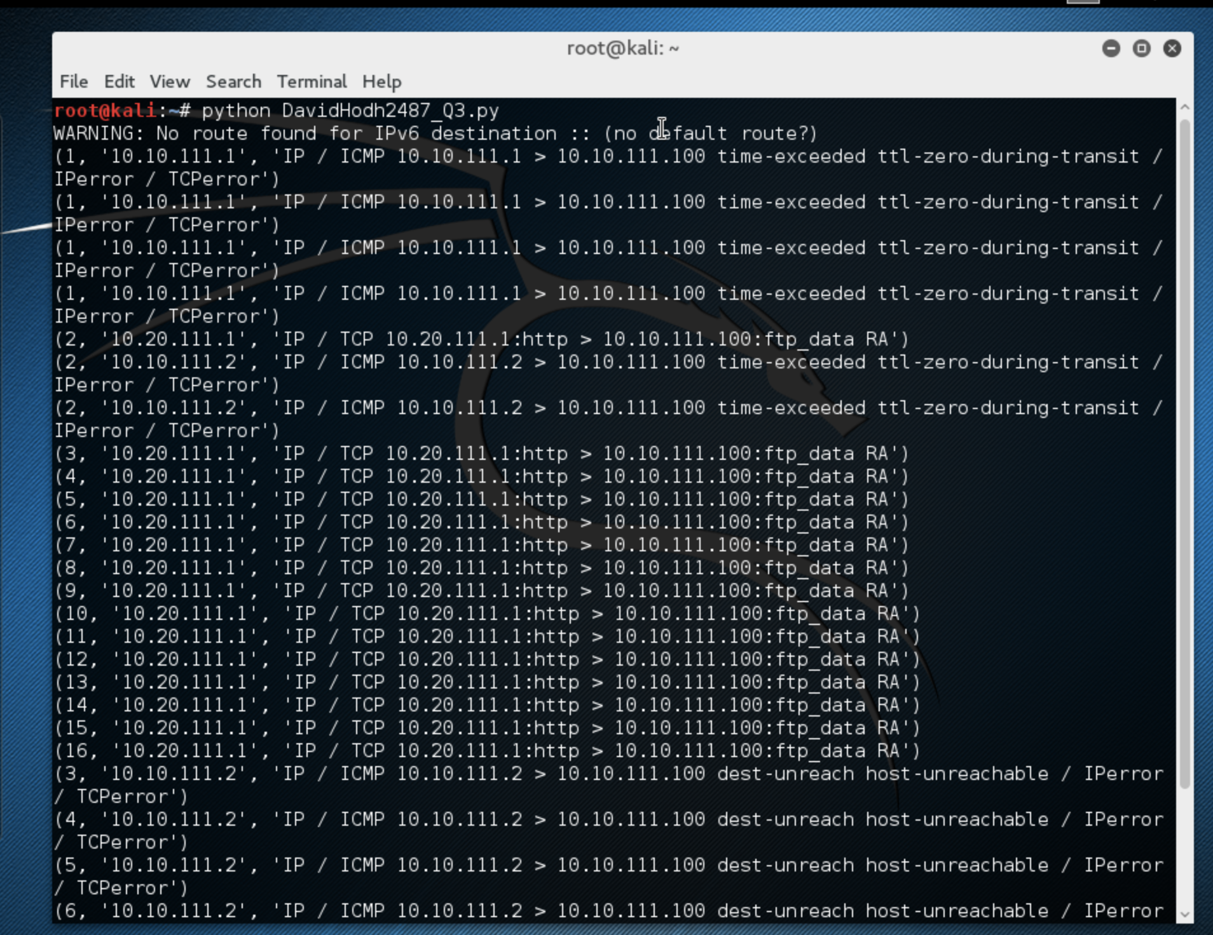

Question 4:

Code:

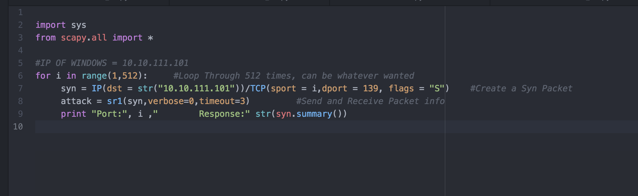

Linux ScreenShot:

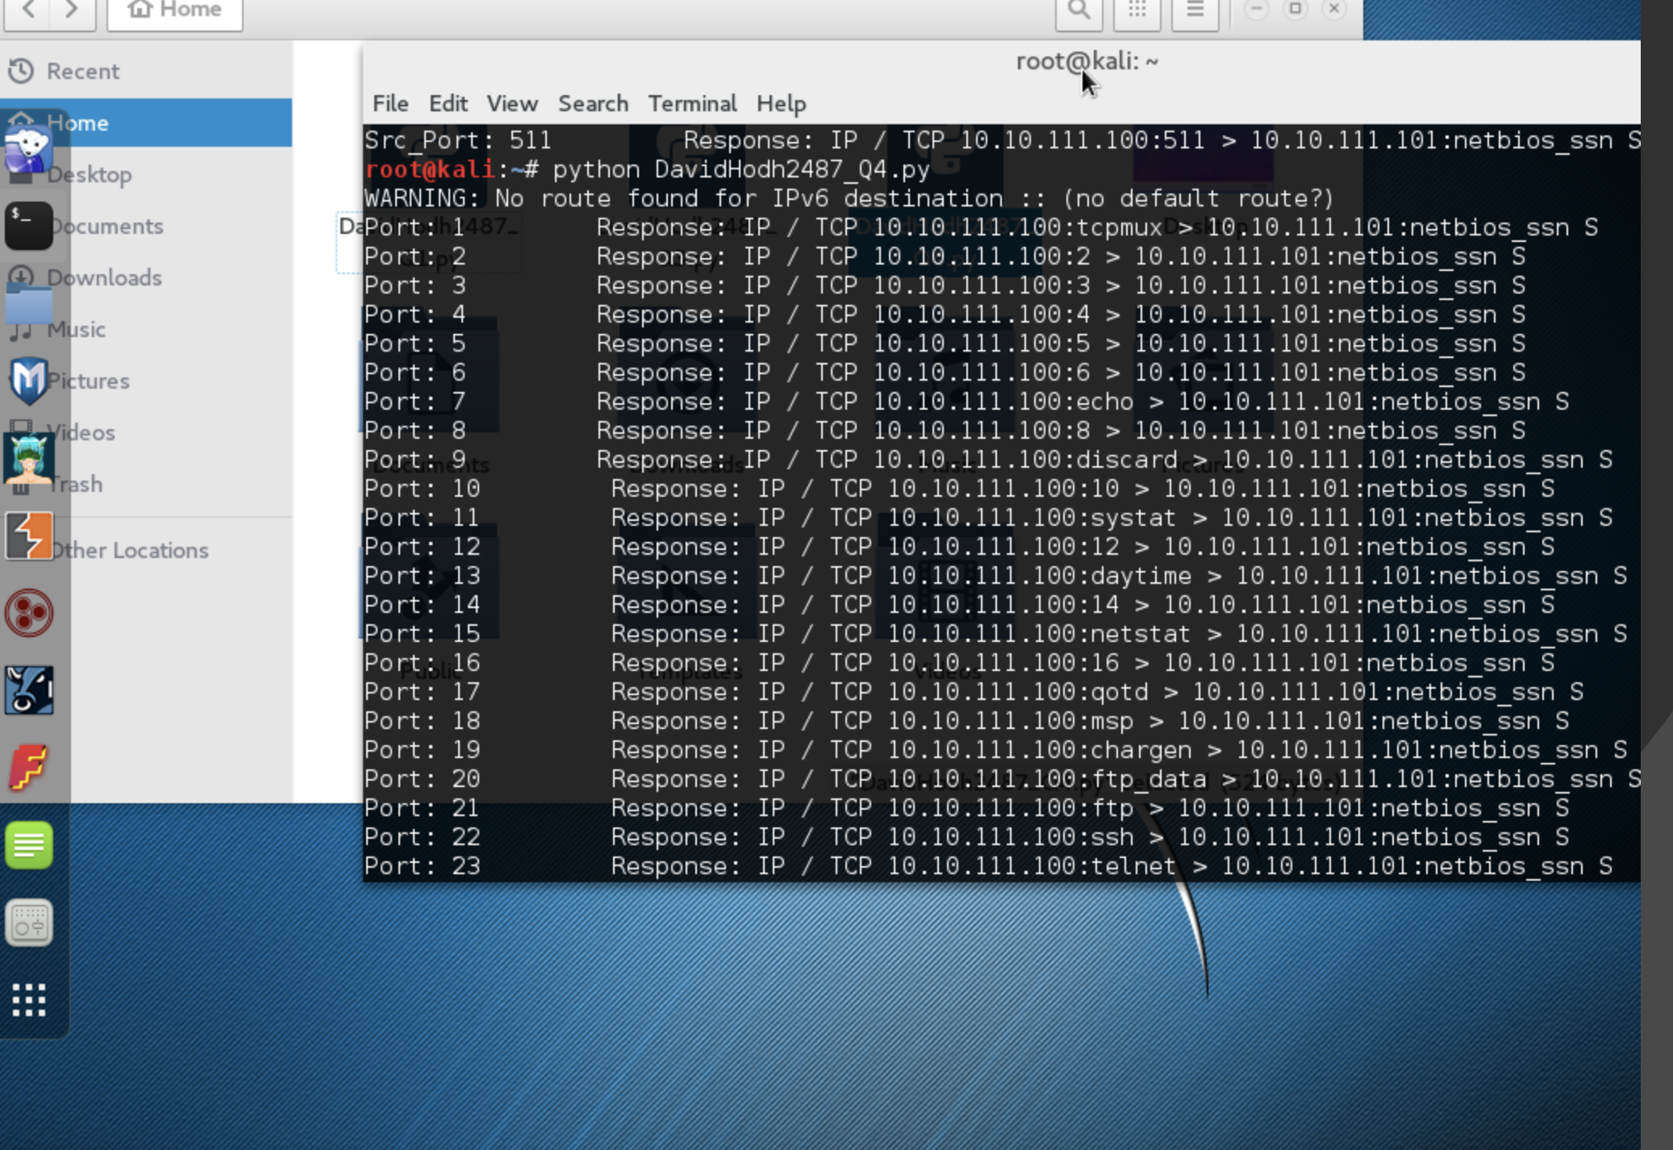

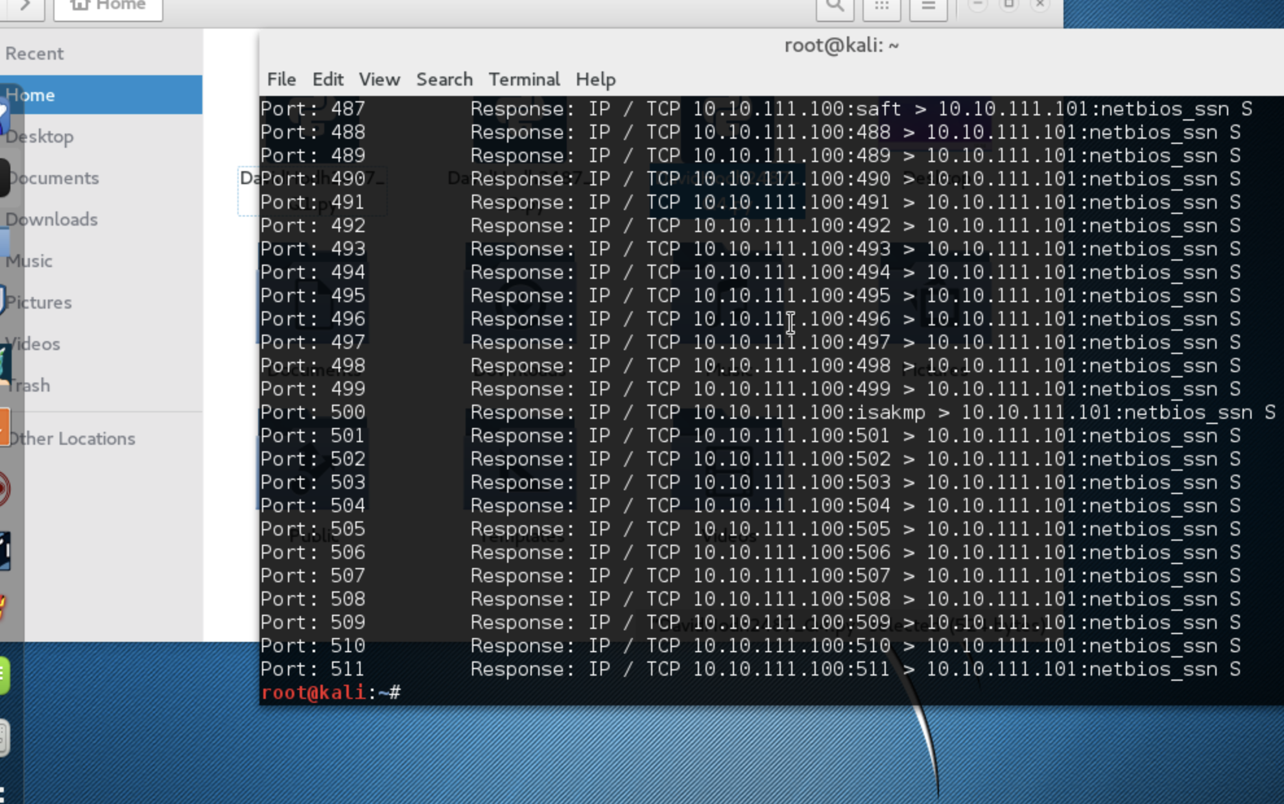

Question 5:

Victim Machine:

